**Final exam BI**

**Roshaan tariq khan 19781**

**Data: garment workers productivity**

Problem statement:

**Does number of workers per team affect the actual productivity?**

Wrangling steps:

* Renamed columns to more appropriate ones
* Changed date type to locale American as it has MM-DD-YYYY type to match data.
* Department had three entries, sweing, finishing and finishing so I combined finishing to one entry. Also renamed sweing to sewing
* Removed work.in.progress column as it has around 50% null rows
* Removed columns idle.time and idle.men as 98% of values in both columns were 0 which means almost all of them did not take idle time and hence is not necessary to analyze
* Changed data type of column team to number
* Change type of column target.productivity to decimal number
* Changed multiple columns from text to numeric
* Rounded down no.of.workers as workers cannot be in decimals
* Changed dp of actual productivity to 2 dp to match targeted.productivity and more coherent analysis.

1. Dimensions(time):

* Date
* Day
* Quarter
* Time.allocation(mins)
* Ovetime.reached(mins)

1. Dimensions(normal):

* Department
* Team
* Financial incentive
* No.of.style changes
* No.of.workers

1. KPI’s:

* Targeted. productivity-
* This column can show the expectations put on a team, maybe differs due to the competency of the teams? This could be a performance indicator since more skills means more expectations from the team
* Actual. productivity-

This is main column which will help solve our problem statement. This column will show us the teams matching the targeted goal in which we will see if number of workers per team affect actual productivity or not.

1. Analysis of charts:

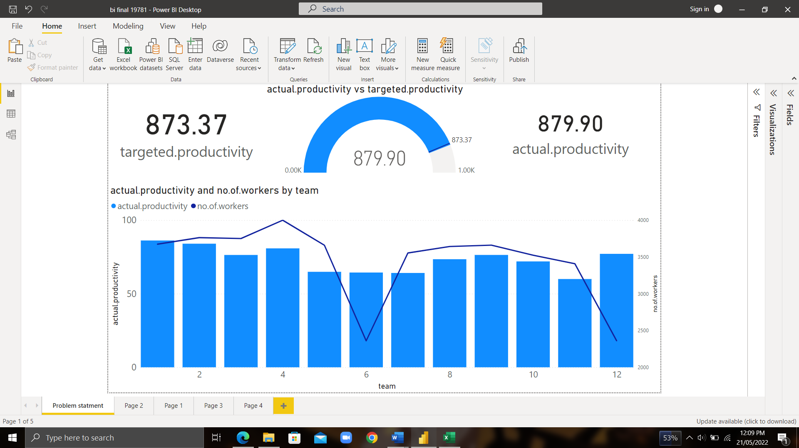

* Our problem statement asked if number of workers per team affected the actual productivity or not. From the line & clustered column chart we can see that as number of workers are decreased, so does the actual productivity. This can be seen with team 6 where they had the least number of workers and hence produced unimpressive results. Team 12 on the other hand worked very impressively with one of the least ,if not the least number of workers.
* 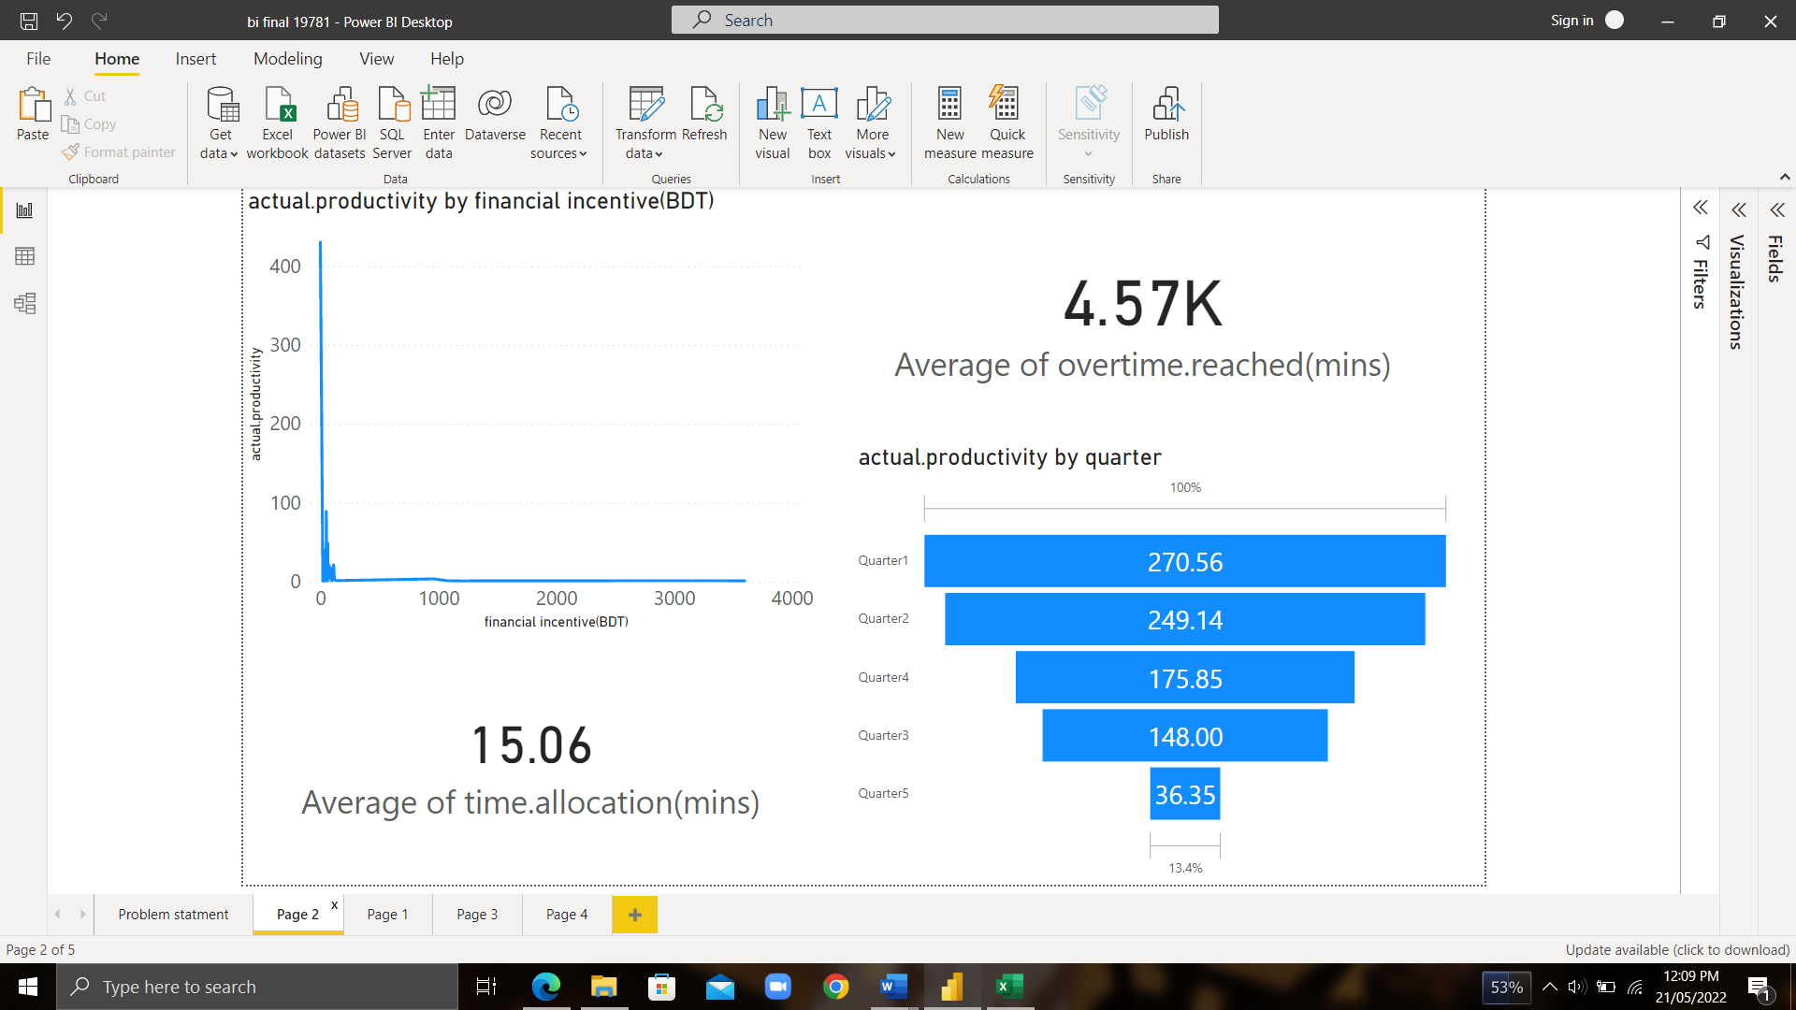It also looks like the targeted productivity metric was achieved and exceeded even thought by a close margin. This means no team fell short of the work they were expected to do.
* From the line chart we can deduce that the financial incentive was not of much help as employees with 0 BDT incentive produced the best results mostly because not everyone was given the incentive in the first place.
* The funnel chart shows that most of the productivity was achieved in the first quarter the month . One reason could be that the employees are more fresh at the start of the month and hence more work is done.
* Employees seem to have worked overtime a lot , which does show in their results from the previous charts. There is a big difference between average time allocation and working overtime average which means most employees were not able to work in the time allocated.

* 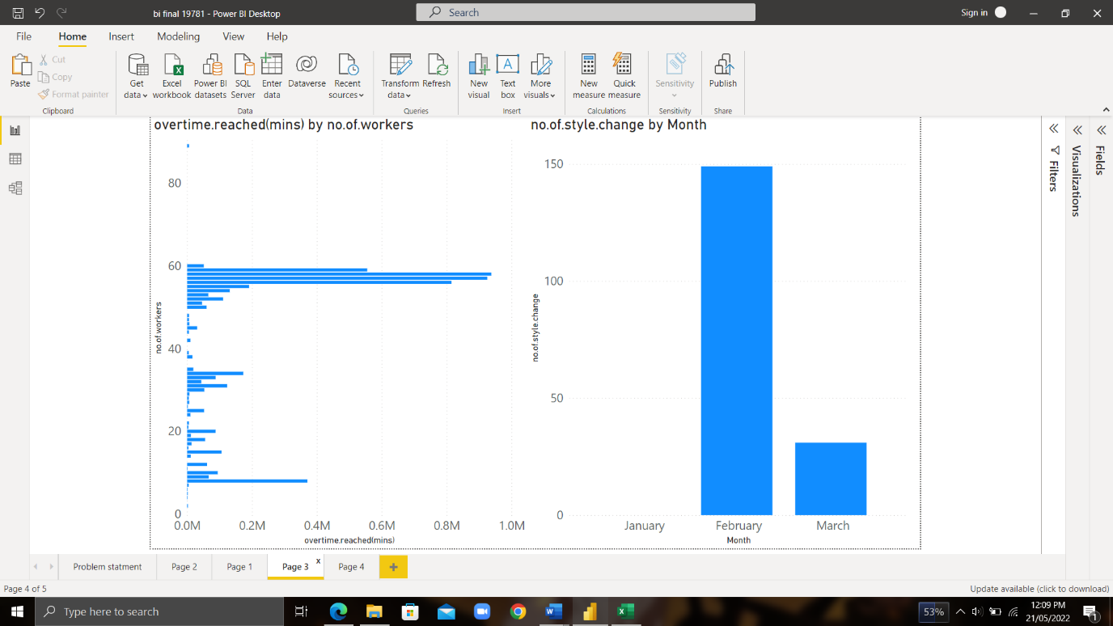The line curve shows the impressive commitment to work by the team members as the targeted productivity was mostly exceeded in every month recorded.
* The clustered bar chart again shows that most employees worked overtime to get the job done .
* The bar chart on the right hand side shows that most of the style changes were done in the month of february whereas none in january. This could mean that , trend of the garments changed suddenly or the employees were told to make some changes. The change in style might have helped them achieve the best productivity between the months JAN, FEB and MARCH. Another thing to note is that the expected productivity was high during february as well which could 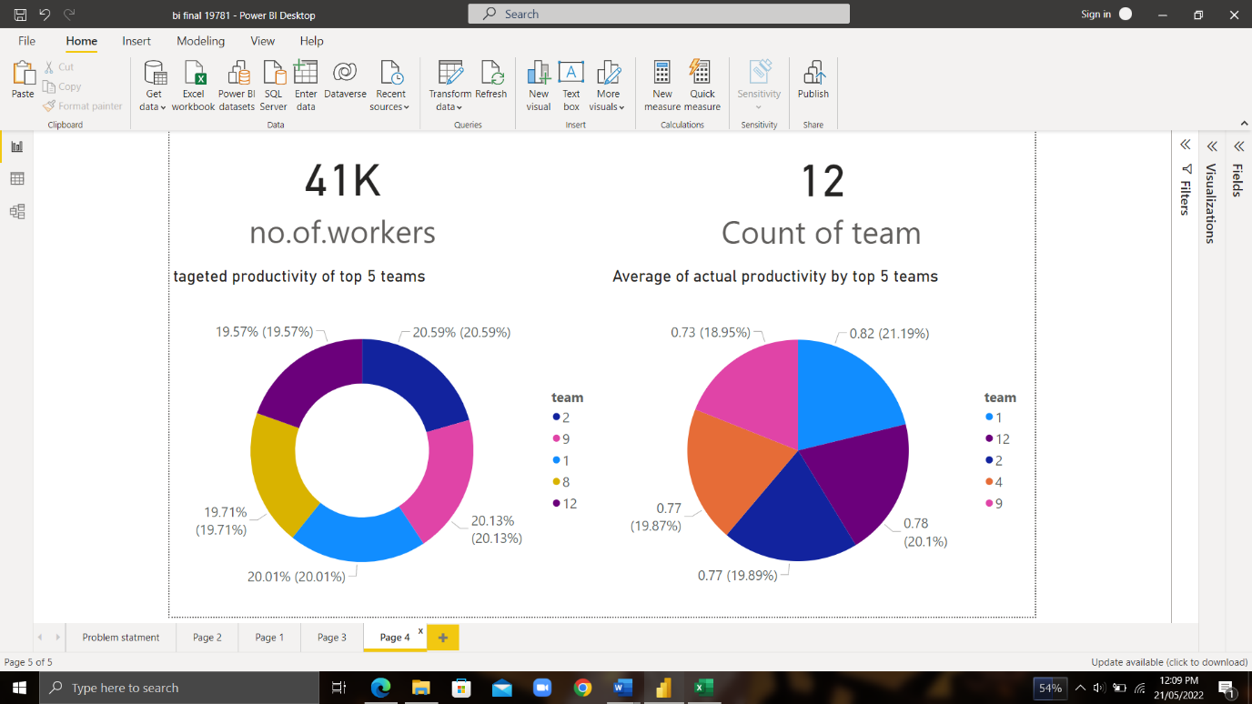confirm my claim of conforming to a new ongoing trend.
* A total of 12 teams had 41,000 workers and were given the task to create garments during a three month period.
* The donut and pie chart shows top 5 teams according to targeted and actual productivity. The donut chart showcases the teams with the most expected productivity which must mean that these teams had the most competent workers. This can be proved by the first graph I made where team 12 had very impressive results with one of the least amount of employees. The pie chart shows that team 1 succeeded in achieving the highest actual productivity amongst all the other teams.
* **Conclusion:**

**My prediction is that team 12 is the best suited team for work as seen in chart 1 they achieved the best results with the least number of employees hence they should be given more financial incentives from now on to further improve on their results. All the other teams have worked neck and neck as well and they too should be given more financial incentive if the expected productivity is to be increased. Incentive might encourage them to work on the expected time so the products can be delivered on time aswell.**

**Regardless of the financial incentive, the teams worked flawlessly and produced desired results.**